HONE
Robotic Inspection & Asset Intelligence Platform
Full-coverage robotic inspection. Real-time digital twins. Enterprise fleet intelligence.
Caelus Industries | caelusindustries.com | info@caelusindustries.com
95%+  Surface coverage per mission | 4 hr  Continuous mission endurance | 0  Confined-space entries required | 24 hr  Digital twin delivery | 200+ hr  MTBF target
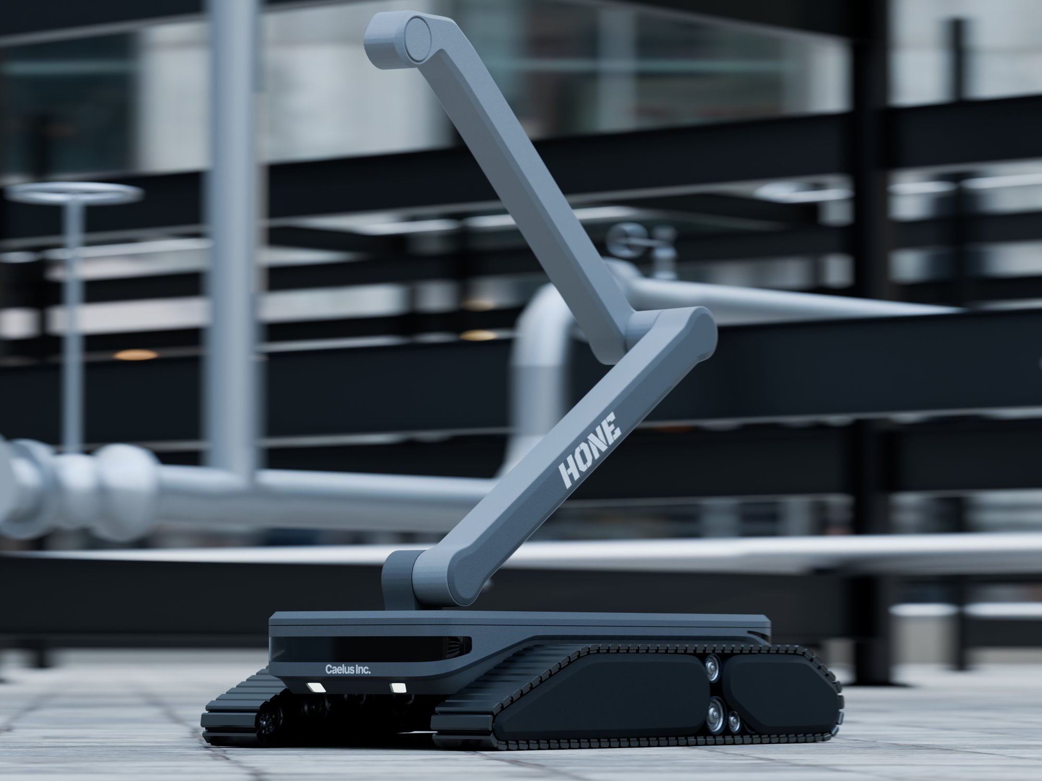
Industrial-grade robotic inspection for any confined or complex environment.
Hone replaces manual inspection with autonomous robotic platforms that deliver complete, georeferenced asset data. No human entry, no guesswork, no gaps. Built on a modular tracked chassis, Hone adapts to oil & gas, chemical processing, power generation, water infrastructure, marine, and industrial manufacturing applications.
COMMERCIAL IN CONFIDENCE | For authorised recipients only | March 2026

1. The Hone Platform

Hone is an integrated robotic inspection and asset intelligence platform. It is composed of three tightly coupled layers: a modular tracked inspection robot, an automated data processing pipeline, and an enterprise software platform that delivers living digital twins, fleet intelligence, and compliance reporting.
Every layer is designed to work together, and each can be adopted incrementally. Customers can start with the robot and software and expand their deployment as their workflows mature.
ROBOT  Modular tracked inspection unit. Configurable sensor payload. Autonomous or teleoperated. Battery or tether-powered. | DATA PIPELINE  On-device and server-side processing. Transforms raw sensor streams into calibrated, georeferenced asset data products. | PLATFORM  Digital twin viewer. Fleet dashboard. Anomaly management. Work orders. Compliance reporting. Cloud or on-premise.

2. The Hone Inspection Robot

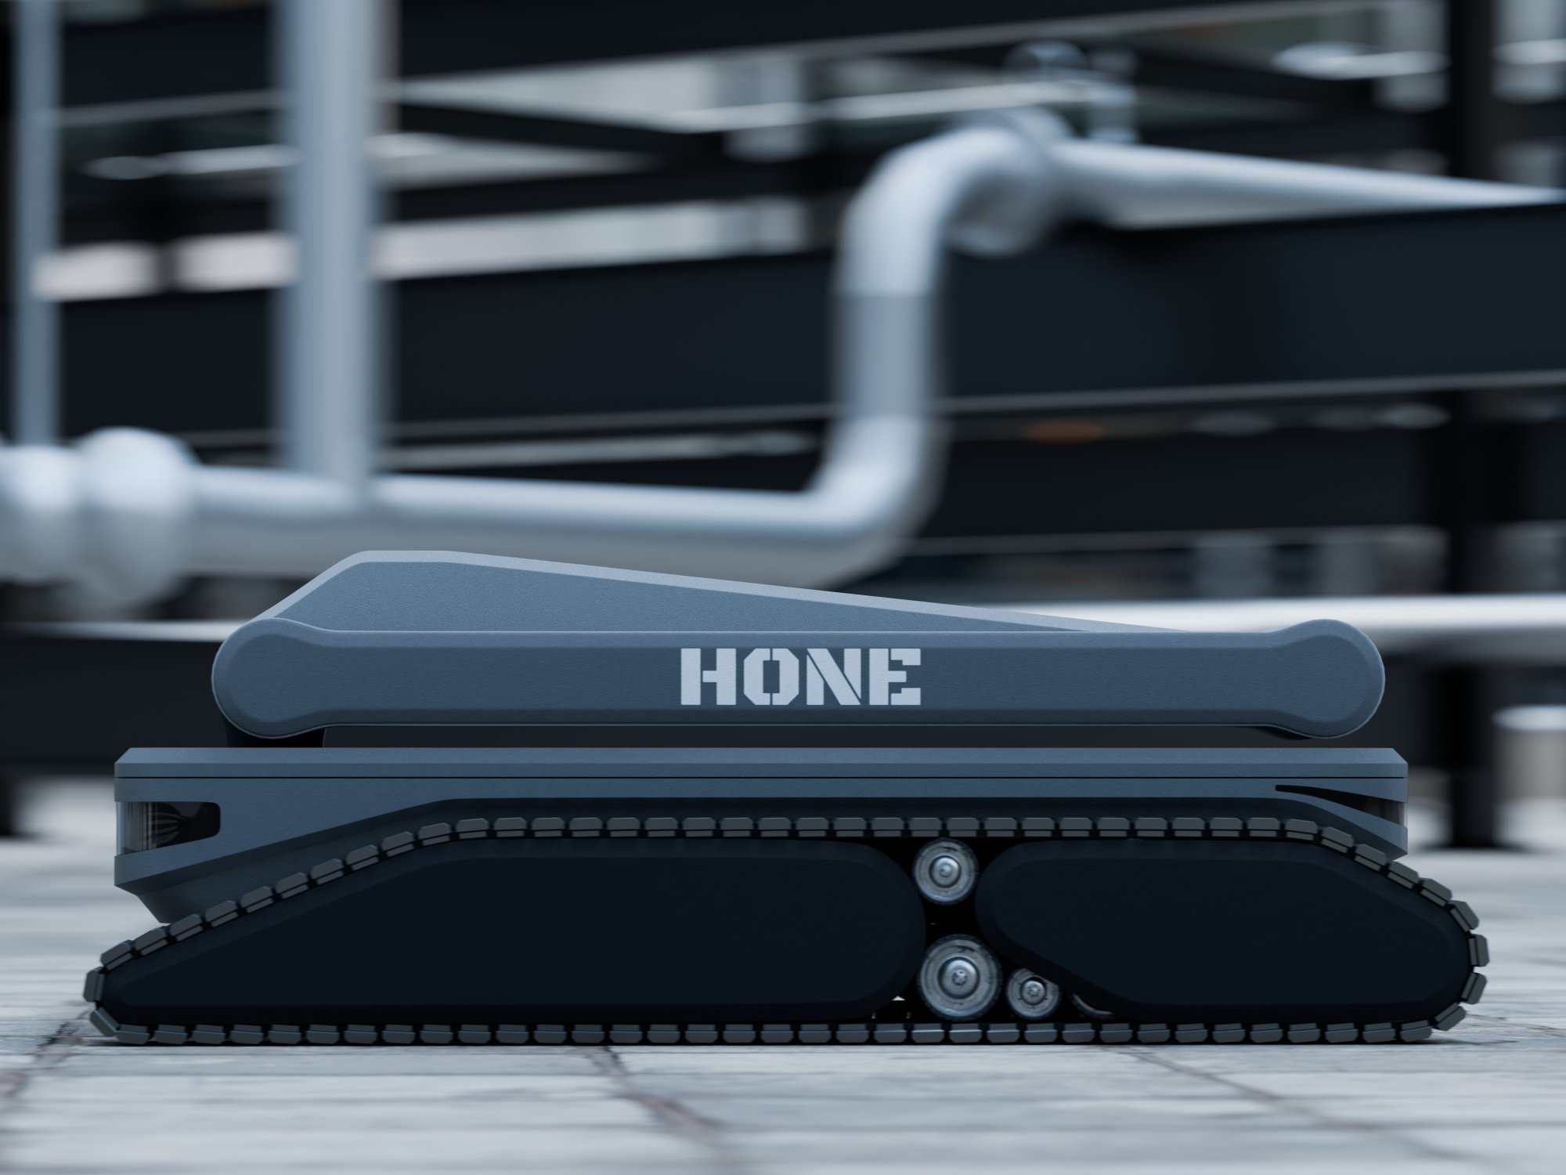 | 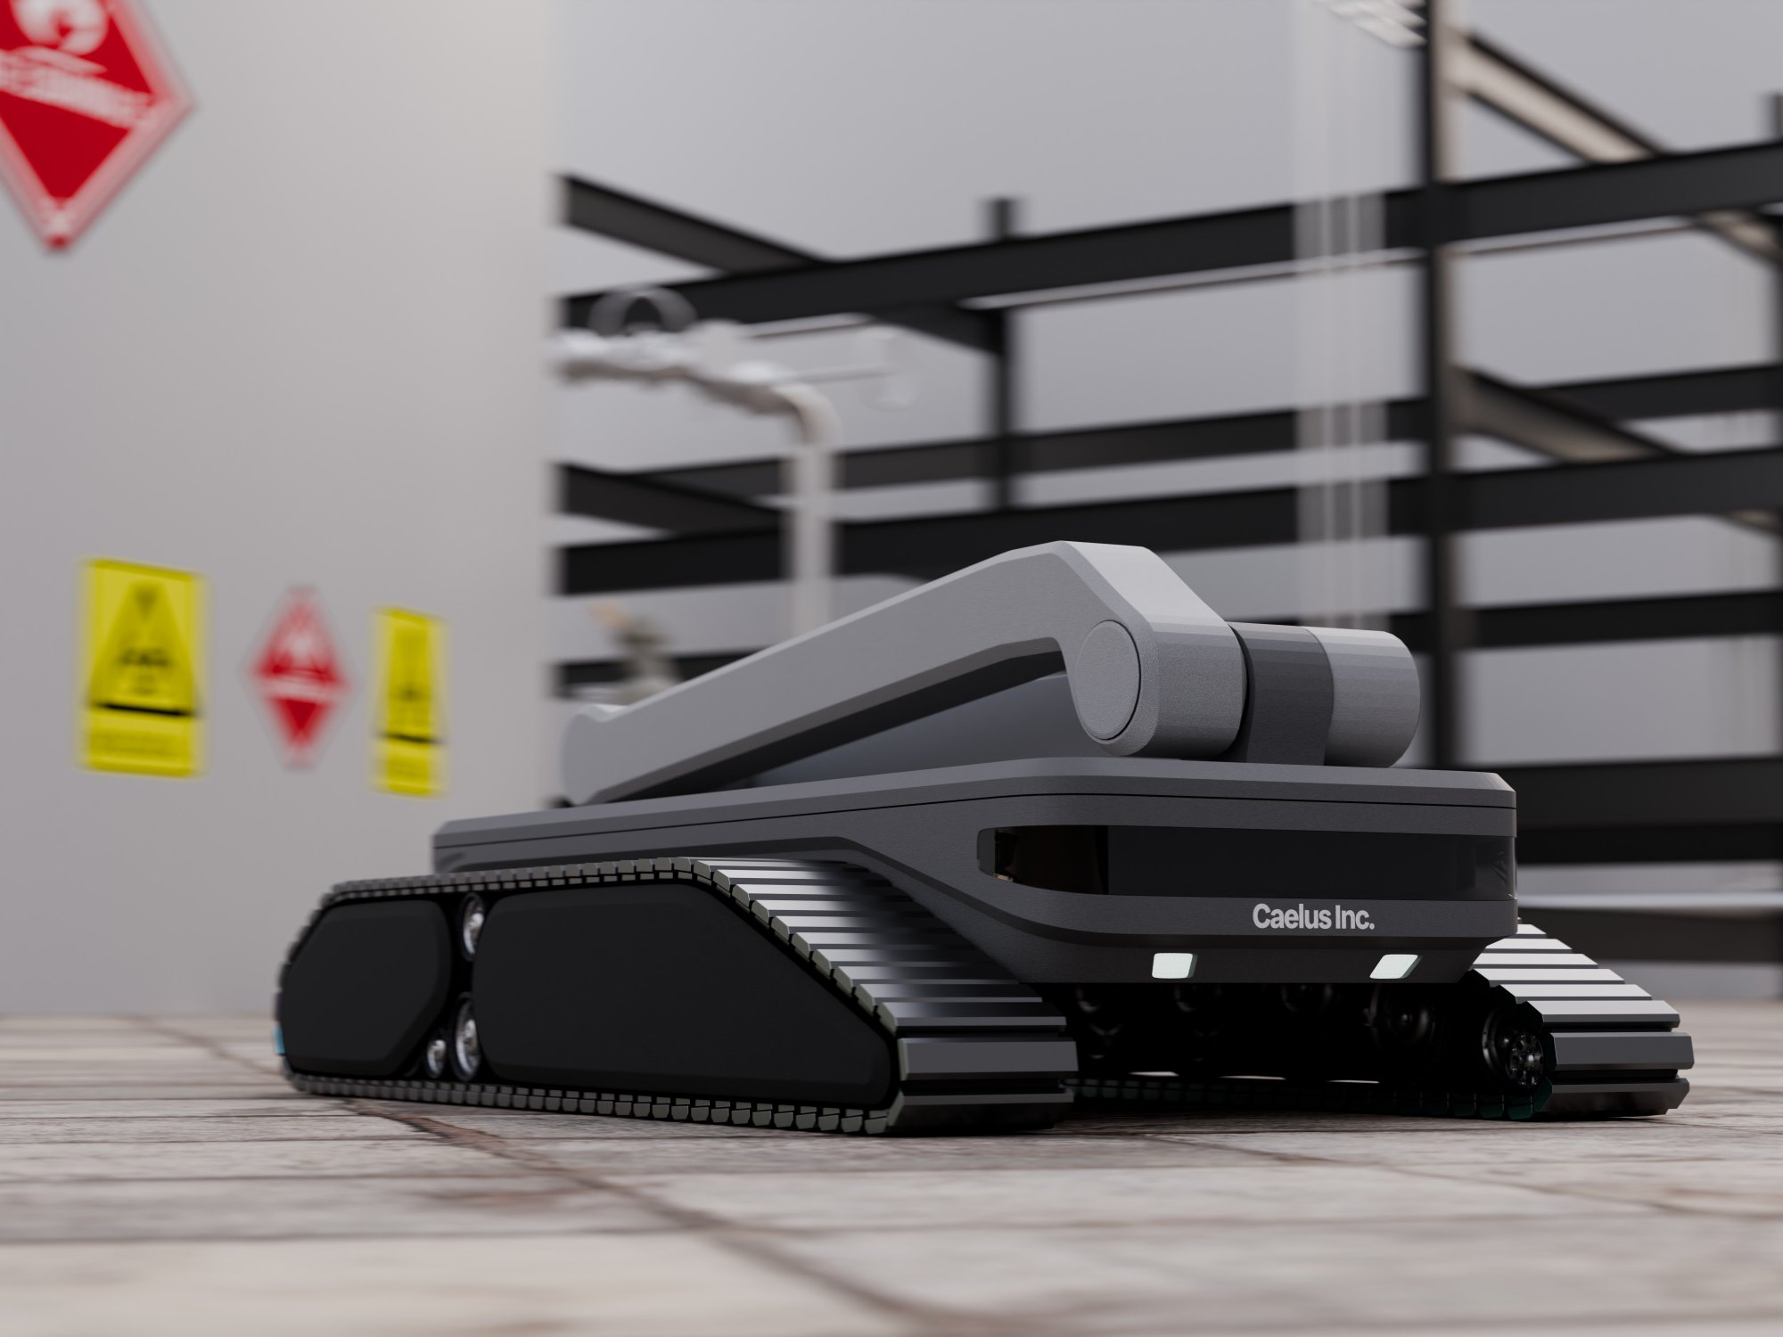
 | 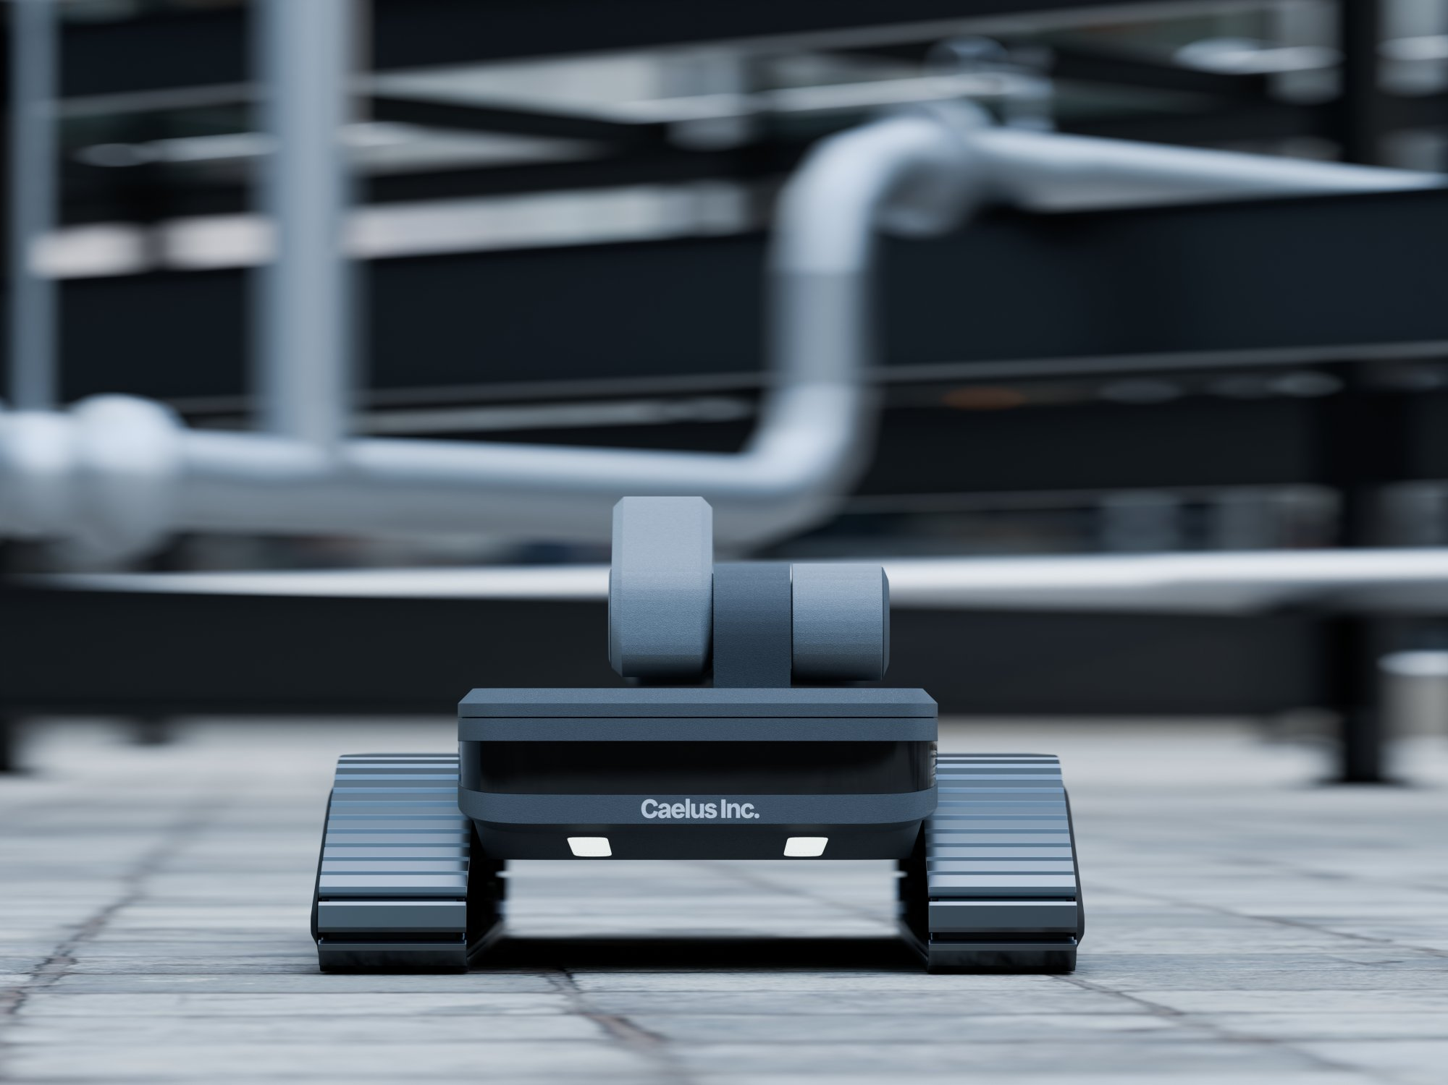
Hone IU-1 inspection unit | Caelus Industries

2.1 Chassis and Locomotion
The Hone inspection unit is built on a rugged tracked chassis engineered for confined, hazardous, and structurally complex environments. Tracks are the standard and tested locomotion system, providing superior traction, stability in sludge and uneven surfaces, and reliable adhesion performance across weld seams and floor irregularities. Wheel configurations are available as a cost-based modification for specific deployment contexts; please consult the Caelus engineering team for requirements.
Specification | Value | Specification | Value
Locomotion | Tracked (standard). Wheel config available. | Adhesion system | Permanent neodymium magnet array
Adhesion safety factor | 5× unit weight on vertical wall and inverted roof | Fail-safe | Held indefinitely on power loss. No electronics required.
Max speed (floor) | 0.30 m/s | Max speed (wall/roof) | 0.15 m/s
Turning radius | Zero (tank-turn in floor mode) | Weld seam crossing | Up to 6 mm proud seam, no adhesion loss
Floor sludge tolerance | Up to 100 mm residual product depth | Surfaces traversed | Floor, shell (vertical), roof underside
Unit weight | 50 kg maximum (fully equipped) | Unit length | 2,000 mm
Deployed footprint | 400 mm width (plan view) | Manhole clearance | 50 mm each side in a 500 mm (20-inch) manhole. Passes 600 mm (24-inch) manholes with ease.
2.2 Power Configuration
The Hone unit ships in one of two power configurations, selected based on mission type and site requirements:
- Battery-operated standalone: modular LiFePO4 battery packs providing 4 hours continuous endurance per pack. Packs are hot-swappable in under 10 minutes without tools, so missions continue uninterrupted. Carry multiple packs for extended campaigns. Ideal for sites where tether routing is impractical or prohibited.
- Tethered control centre: 600 W continuous power via 50 m (up to 100 m with repeater) tether carrying power, data, mechanical safety line, and gas abort signal. Preferred for long-duration missions and facilities with established control infrastructure.
Both configurations share an identical robot chassis and sensor payload.
Power Spec | Value | Power Spec | Value
Battery chemistry | LiFePO4 (lithium iron phosphate) | Usable capacity | 1,000 Wh minimum
Charge time | Under 2 hours (10% to 100%) | Battery swap | Under 10 minutes, tool-free hot-swap. Run successive missions with spare packs.
Tether power | 600 W continuous (external supply) | Bus voltage | 48 V DC nominal
Tether length (std) | 50 m with motorised active-tension reel | Tether length (ext) | Up to 100 m with repeater
2.3 Modular Sensor Suite
The Hone chassis is designed to be modular. Sensor payloads are selected and configured based on application. Standard oil & gas inspection units carry the full sensor suite below; industrial variants can be equipped with subsets appropriate to the use case.
Sensor | Specification
Phased-Array UT (PAUT) | Wall thickness 3 mm to 50 mm. ±0.1 mm accuracy. 3 mm scan grid. Temperature-compensated. Calibrated to ASME Section V. Automatic couplant dispensing.
4K Visual Cameras (×2) | Dual 4K RGB at 30 fps, global shutter. 360° high-CRI LED illumination. Frame-accurate georeferencing to tank coordinate model. Drives AI coating condition assessment.
LiDAR (3D point cloud) | Multi-beam rotating LiDAR. 40 m range. 0.1° angular resolution. 10 Hz scan rate. Real-time SLAM localisation and point cloud generation for digital twin.
Sonar (sludge mapping) | Downward-facing ultrasonic sonar. 50 mm footprint resolution. 0 to 500 mm depth range. Produces sediment volume heatmap across full tank floor.
Gas detection (safety) | Catalytic bead / IR hydrocarbon 0 to 100% LEL + electrochemical H2S 0 to 100 ppm. Hardware abort at 10% LEL / 10 ppm H2S. T90 response under 10 s. Battery-independent.
IMU + wheel odometry | 9-axis IMU at 200 Hz fused with 4-channel quadrature wheel encoders at 100 Hz. 1 ms hardware clock synchronisation across all sensors. Dead-reckoning input to SLAM.
2.4 Technical Specifications
Environmental | Value | Build Quality | Value
Operating temp | -10°C to +55°C | Chassis material | 316L stainless steel / 6061-T6 aluminium
Storage temp | -20°C to +70°C | Seals | FKM / Viton throughout. Oil and H2S rated.
Humidity | Up to 100% RH (condensing) | Ingress protection | IP67 (IP68 preferred on main body)
Product immersion | Crude, diesel, naphtha, HFO to 100 mm | H2S tolerance | Up to 50 ppm (sour service tanks)
Impact resistance | 1 m drop, any orientation, no loss of function | MTBF | 200+ operating hours

2.5 Hazardous Area Certification
Standard / Classification | Value
ATEX Zone | Zone 1 (explosive atmosphere present intermittently)
Gas group | IIB (covers petroleum vapours, propane, and H2S)
Temperature class | T3 minimum (T4 targeted)
EU certification | ATEX Directive 2014/34/EU, EN 60079 series
International certification | IECEx scheme, IEC 60079 series
Protection concept | Ex ia (intrinsic safety) for sensors; Ex d / Ex e for enclosures
System certification | Entire unit certified as a system, not components only
2.6 Built-in Safety Systems
Safety systems are hardware-enforced, not software-dependent. Critical protections remain active regardless of software state.
Hardware Gas Abort | Fail-Safe Magnetic Adhesion | Emergency Stop
If hydrocarbons exceed 10% LEL or H2S exceeds 10 ppm, all drives stop and an abort signal fires instantly. Computer failure cannot prevent the abort. | Permanent neodymium magnets hold the unit to any steel surface even with complete power failure. No electronics are required to maintain adhesion. The unit stays put until safely retrieved. | Hard-wired stop on the control cabinet and operator tablet. Under 100 ms from button press to motor disable. Two-step reset prevents accidental resumption.
2.7 Operating Modes
- Autonomous: the unit navigates and acquires data without operator input. SLAM-based path planning with full-surface coverage.
- Teleoperated: operator controls movement from outside the asset using the ruggedised field tablet or above-ground control cabinet.
- Hybrid: autonomous operation with operator override at any point. No mission abort required to switch modes.
- Regulatory mode lock: facility-level configuration restricts permitted modes where required by local regulation or HSE policy.
2.8 Deployment
Deployment Spec | Value | Deployment Spec | Value
Setup time | Under 60 minutes, two technicians | Training to operate | Under 3 hours (deployment + platform + teleoperation)
Required crew | Two field technicians. No confined-space entry. | Data offload | USB 3.2 direct or Wi-Fi; 500 GB in under 20 minutes
Operator interface | Ruggedised industrial tablet (IP65, MIL-STD-810H) | Above-ground equipment | Portable control cabinet: PSU, reel, display mount
Offline operation | Fully functional with no internet or site network | Entry requirement | 400 mm width fits standard 500 mm (20-inch) and 600 mm (24-inch) manholes

3. Industrial Applications

The Hone chassis is an industrial robotic platform first. The same tracked magnetic platform and modular sensor architecture adapt to any application requiring inspection, mapping, or monitoring of confined, hazardous, or structurally complex environments. The same chassis is also the foundation of the Hone industrial cleaning robot, which shares components and control systems for multi-role deployment.
Industry | Applications | Key Sensor Payload
Oil & Gas | Above-ground storage tanks, pipelines, pressure vessels, FPSOs, offshore ballast tanks, jetty structures | PAUT UT, LiDAR, 4K visual, sonar, gas detection
Chemicals & Petrochemicals | Process vessels, reactors, storage spheres, chemical feedstock tanks, containment cells | PAUT, visual AI (coating/corrosion), gas detection, thermal
Power Generation | Turbine casings, boiler drums, condensers, cooling towers, penstocks, underground vaults | UT thickness, SLAM mapping, LiDAR, visual inspection
Water & Wastewater | Potable water tanks, raw water reservoirs, digester tanks, sewer infrastructure, dams | UT, LiDAR 3D mapping, visual inspection (no hazardous area req.)
Marine & Offshore | Ship double-bottom tanks, ballast tanks, void spaces, hull interior inspection, FPSO cargo tanks | PAUT, LiDAR, 4K visual, sonar, full ATEX suite
Mining & Minerals | Tailings tanks, slurry vessels, ore storage silos, leach tanks, flotation cells | UT, sonar (slurry volume), visual AI, full sludge mapping
Food & Beverage | Fermentation vessels, silo interiors, large storage tanks, processing vessels | Visual inspection, LiDAR mapping (no explosive atmosphere sensors required)
Nuclear / Regulated | Containment vessels, spent fuel pools, waste storage, radiation-zone structures | Custom sensor payload; shielded electronics on request
Defence & Military | Fuel storage inspection on military bases and naval vessels, confined-space reconnaissance, IED and ordnance detection in enclosed structures, tunnel and bunker mapping, ship hull and ballast tank inspection without confined-space entry | LiDAR SLAM mapping, 4K visual, UT, gas detection, EO/IR camera, optional payload hardening for EMI environments
Military logistics & infrastructure | Underground storage tank inspection, aircraft hangar fuel pit inspection, forward operating base infrastructure survey, ammunition storage vault condition assessment | Modular sensor payload configured per mission type; comms-independent offline operation standard
Industrial cleaning | Same chassis deployed as a multi-tool cleaning robot for tank sediment removal and surface preparation | Cleaning head module replaces or supplements inspection sensor payload
Sensor payloads, chassis configuration, and software data layers are scoped to the specific industry and application during the pre-deployment engineering review. Lead time for non-standard configurations is discussed in Section 5.

4. Hone Platform Software

Every robot mission feeds directly into the Hone operating platform. The platform transforms raw sensor data into a continuously updated digital intelligence layer for every asset in your fleet. It is available as a cloud-hosted web application or as an on-premise installation on customer-managed hardware, including fully air-gapped offshore and remote deployments with no internet dependency. The same software runs identically online and offline — connectivity is optional, not required.
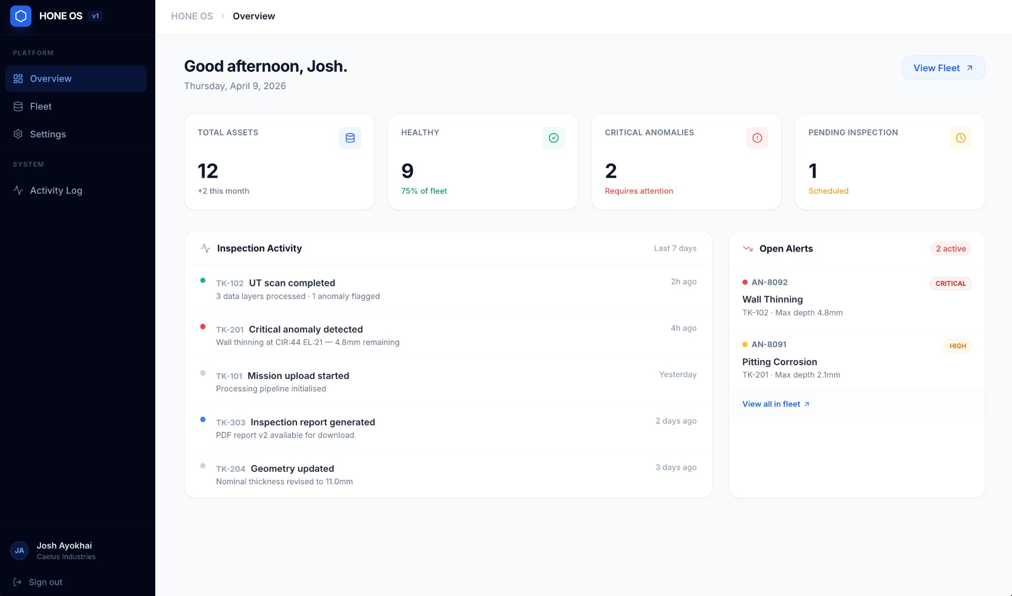
Hone OS — Overview dashboard. Fleet health summary, recent inspection activity, and open alerts — accessible from any browser, on-site or remotely, with or without internet.
4.1 Digital Twins and Site Intelligence
The Hone platform creates and maintains a living digital twin for every inspected asset. A digital twin is not a static 3D model. It is a versioned, continuously updated representation of the asset's physical state, integrating geometry, sensor data, AI-classified findings, and computed health metrics into a single queryable object.
- Interactive 3D viewer: full-resolution point cloud and mesh model rendered in the browser. Orbit, pan, zoom, and navigate the interior of any asset. Maintains over 20 FPS at 500 million points on a standard workstation.
- Toggleable data layers: UT thickness heatmap, coating condition map, sludge depth overlay, anomaly markers, coverage map, all rendered as spatial overlays on the 3D model. Switch any layer on or off in real time.
- Georeferenced anomalies: every defect, corrosion pit, and coating failure is positioned in 3D space to within 50 mm. Click any anomaly marker to open the full detail panel with thickness readings, photo evidence, and trend history.
- 2D floor heatmaps: top-down thickness projection for quick overview analysis. Green-amber-red colour scale referenced to minimum acceptable thickness per applicable standard.
- Inspection comparison: side-by-side split view of any two inspection snapshots. Synchronised camera controls. Thickness delta overlay highlights exactly where metal has been lost between cycles.
- Recordings and mappings: all 4K video, point clouds, and sensor logs are stored and accessible. Navigate any surface recording frame-accurate to its position in the tank. Export point clouds in E57 or LAS format for use in third-party engineering software.
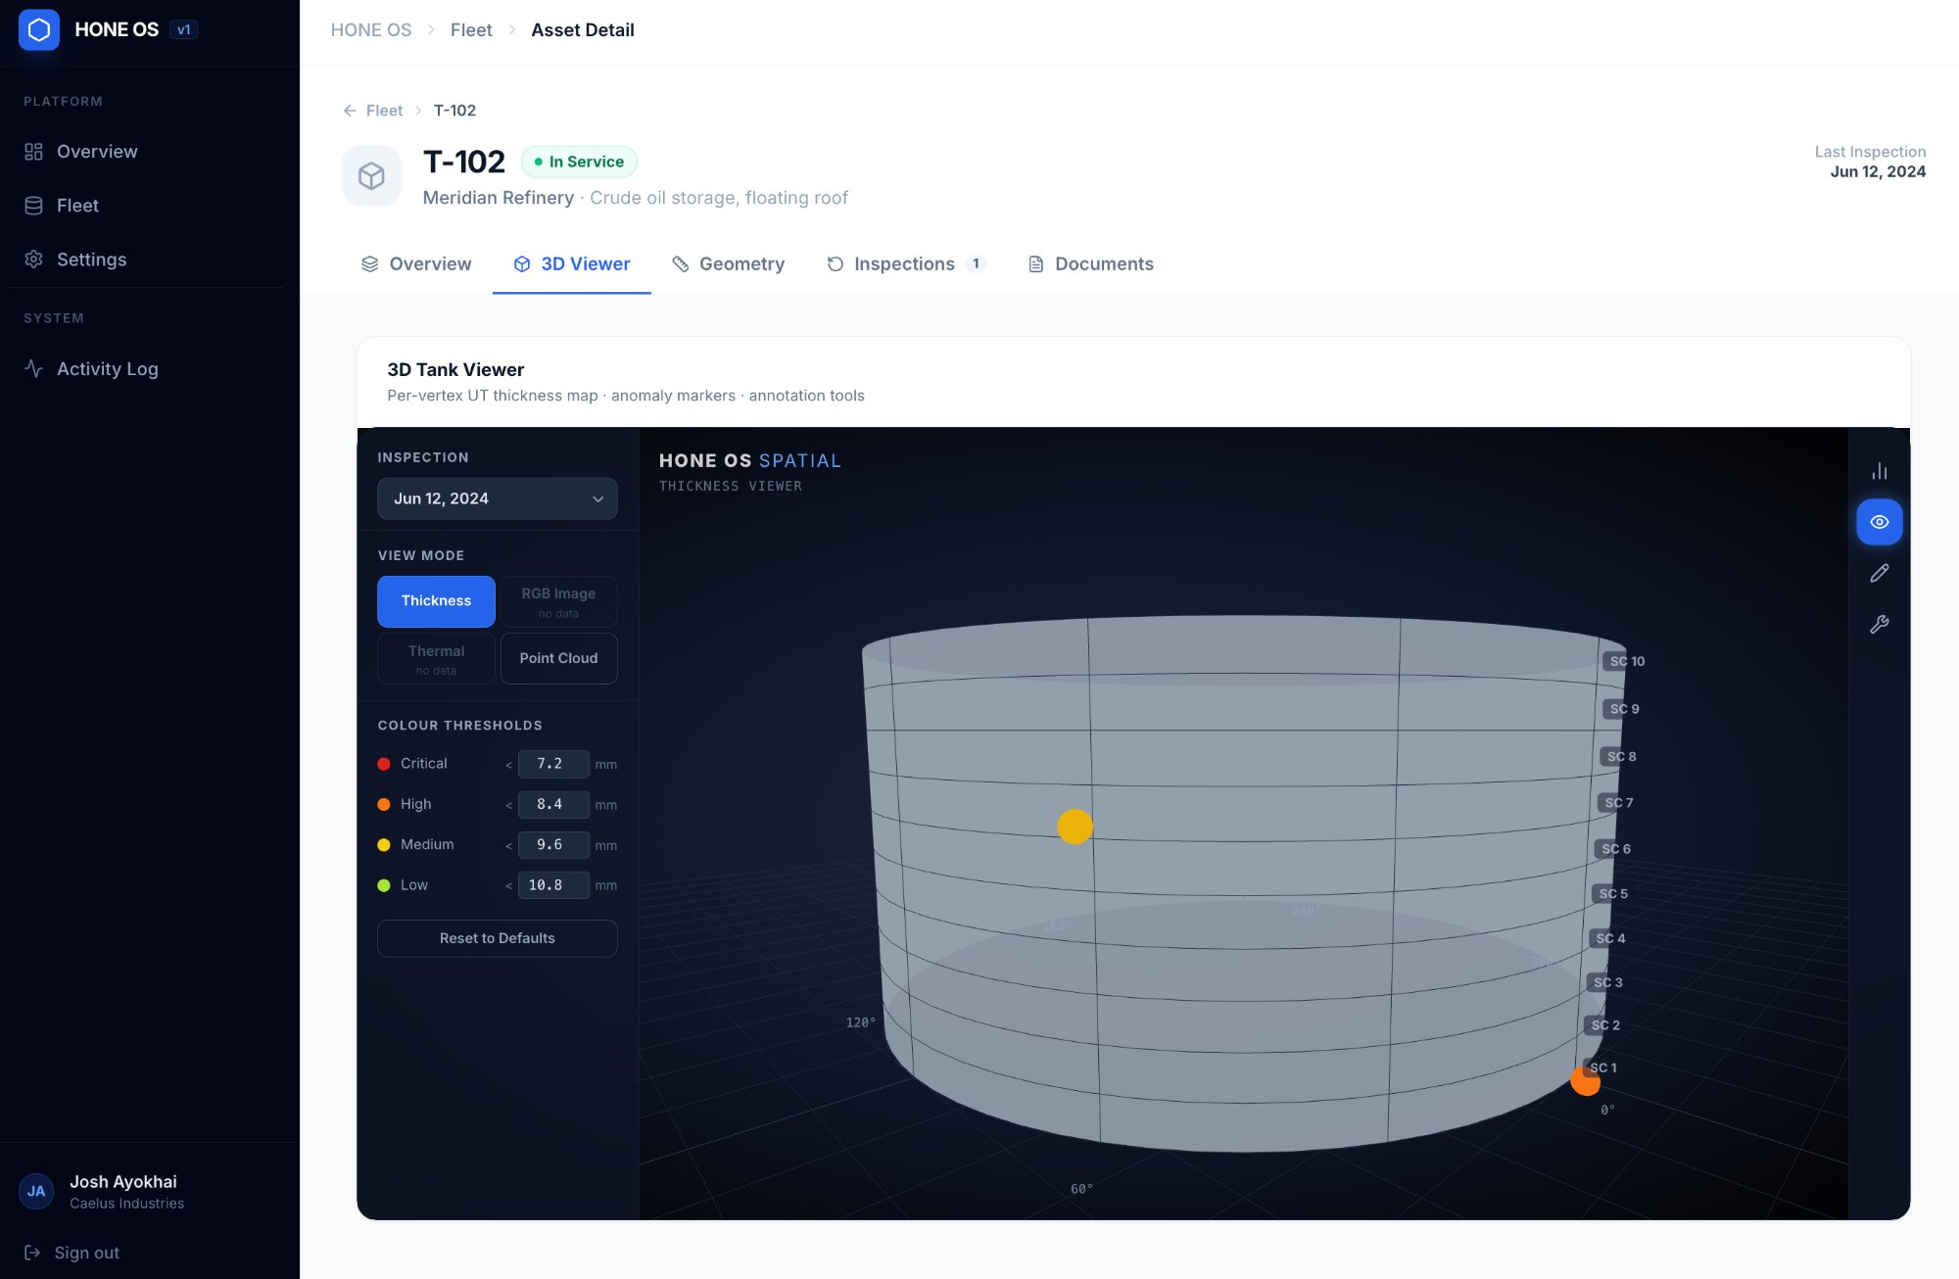
Hone OS — 3D Tank Viewer. Per-vertex UT thickness map rendered on a full 3D model of the asset. Anomaly markers pinned at georeferenced locations. Colour thresholds configurable per organisation standard.
4.2 Fleet Management and Risk Intelligence
The fleet dashboard gives operations managers and integrity engineers a real-time picture of asset health across their entire facility, with risk-ranked prioritisation and automated alerting.
- Fleet dashboard: all assets at a glance. Colour-coded health badges (green / amber / orange / red) derived from live risk scores. Summary strip showing critical anomalies, overdue inspections, and average fleet risk.
- Risk scoring engine: computed risk score (0 to 100) per asset, updated automatically after each inspection. Formula combines wall thickness ratio, corrosion rate, remaining useful life urgency, and inspection overdue factor. Weights are configurable per organisation.
- Risk prioritisation: tanks ranked by risk score with recommended action labels: Immediate Review, Schedule Inspection, or Monitor. Helps planners allocate inspection budget and maintenance windows.
- Delta analysis: every new inspection is automatically compared to the previous one. New anomalies, resolved anomalies, accelerating corrosion, and thickness changes are surfaced prominently.
- Corrosion trend charts: time-series charts showing average and minimum wall thickness across all inspection cycles, with reference lines for nominal and minimum acceptable values.
- Alerts panel: configurable alerts for new critical/high anomalies, inspection overdue, processing failures, and accelerating corrosion. Acknowledged in-app; optionally delivered by email.
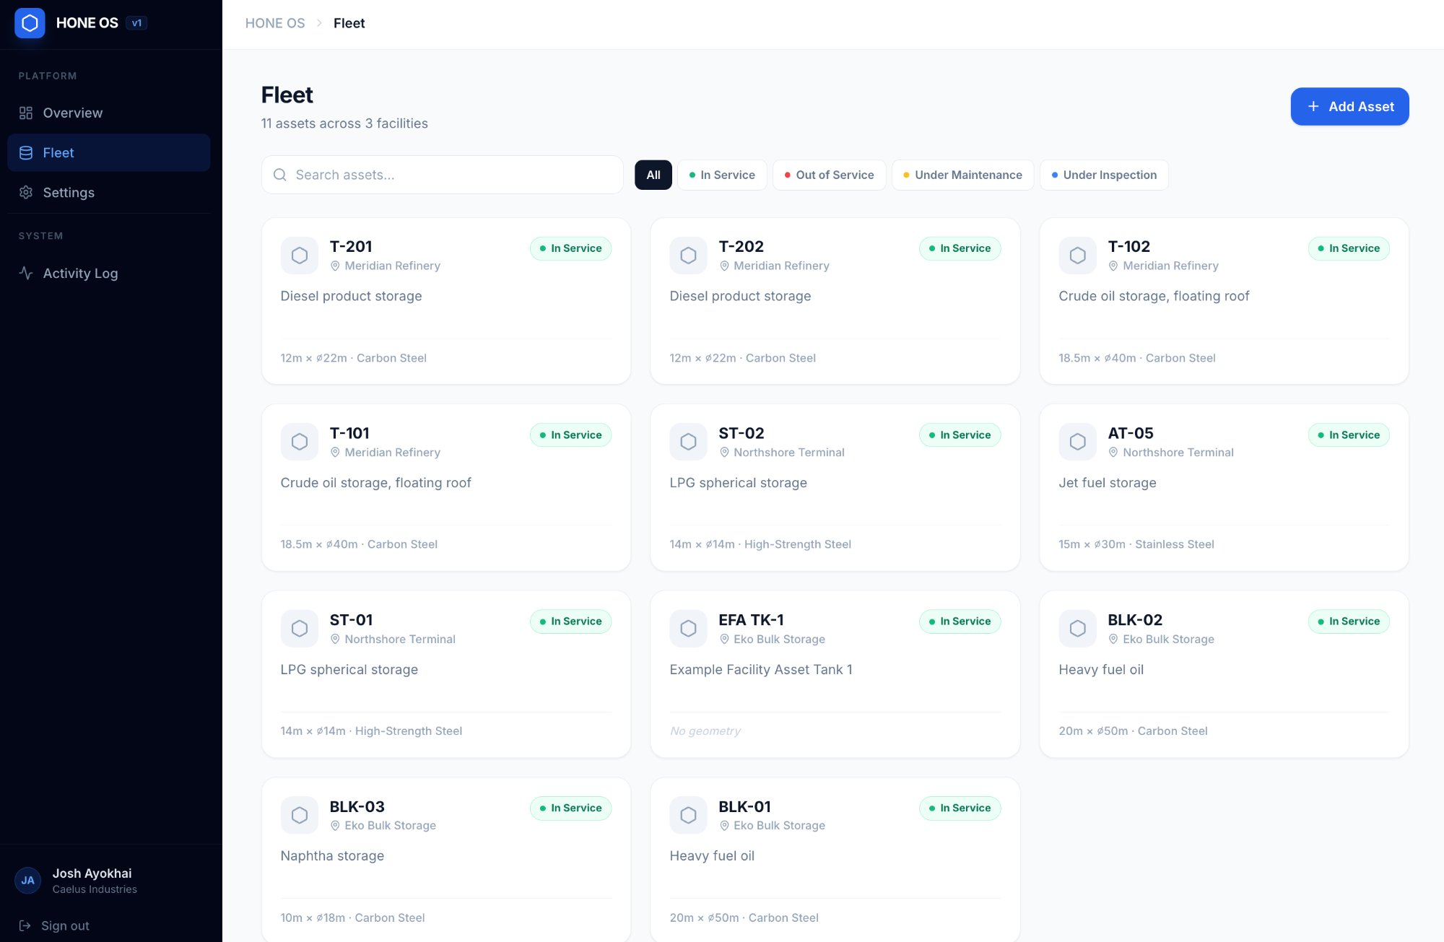
Hone OS — Fleet view. All assets across all facilities in a single view. Status, material, geometry, and facility at a glance. Filter by status, search by tag, or add new assets directly from the dashboard.
4.3 Anomaly Management and Work Orders
The platform provides a structured workflow for managing findings from detection through to resolution, replacing disparate spreadsheets and PDF reports with a single auditable system.
- Anomaly register: filterable, sortable table of all findings across all inspections for any asset. Columns include type, severity, surface, location, measured thickness, corrosion rate, estimated remaining life, and status.
- Status workflow: each anomaly moves through a defined status lifecycle (Open, Under Review, Actioned, Closed, or False Positive) with user, timestamp, and notes recorded at each transition.
- Work orders and notes: engineers can attach notes, assign anomalies to team members, and link findings to maintenance actions. All activity is logged in the anomaly history.
- Bulk actions: assign, change status, or export selected anomalies to CSV for integration with external CMMS or work management systems.
- AI-assisted classification: anomaly types and severities are initially classified by the AI pipeline. Engineers can confirm or override classifications; feedback is retained for model improvement.
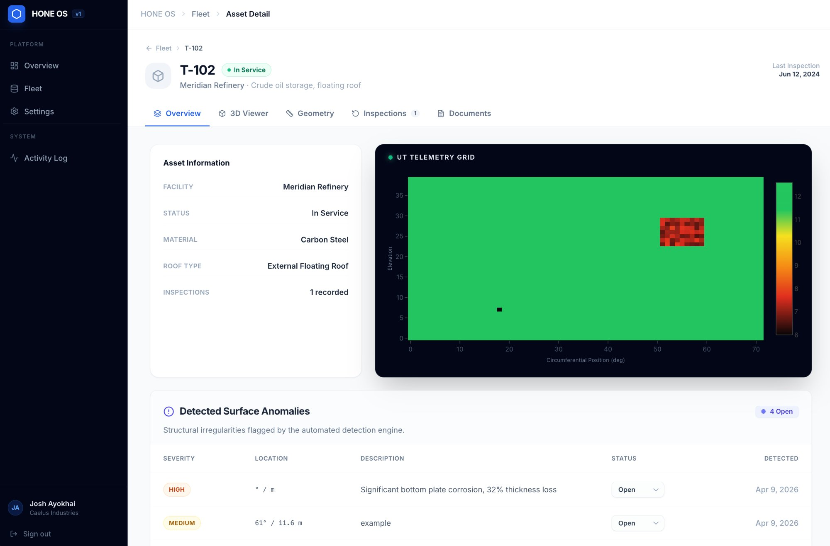
Hone OS — Asset Detail. UT telemetry grid showing wall thickness distribution across the full tank shell. Detected surface anomalies listed below with severity, location, description, and status — each linked to the georeferenced position on the 3D model.
4.4 Live Mission Monitor
When a Hone unit is actively deployed and connected to the site network, the Live Mission Monitor provides real-time visibility and control.
- Live video feed: real-time camera stream from the inspection unit to the operator tablet or browser, with latency under 500 ms and full-screen capability.
- Real-time coverage map: 2D top-down projection of the asset updating as the unit moves. Unit position shown as a live icon. Coverage percentage tracking in real time.
- Telemetry panel: battery level, gas sensor readings (LEL and H2S with colour-coded thresholds), tilt angle, connection strength, and current operating mode. All live.
- Teleoperation controls: directional movement controls (on-screen or keyboard), speed slider, and manual sensor trigger for UT or photo capture at any position.
- Gas alert overlay: full-screen amber overlay at 5% LEL warning threshold, full-screen red at 10% LEL danger threshold with audible alert and automatic emergency stop.
- Mission controls: Pause, Resume, and Abort buttons with confirmation and reason logging. Emergency stop always visible and always active.
4.5 Reporting and Compliance
- Automated inspection reports: AI-generated PDF reports structured to API 653 and EEMUA 159 requirements. Includes cover page, executive summary, full thickness results, anomaly register, corrosion rate analysis, remaining life assessment, and calibration records.
- Engineer review step: AI-generated executive summary is presented for engineer review and approval before report finalisation. Engineers can edit or regenerate.
- Report versioning: each generated report is stored immutably. New versions can be created; originals are always retained for audit purposes.
- Data exports: UT readings, anomaly register, and coverage data exportable as CSV and JSON for integration with CMMS, data warehouses, or regulatory submission systems.
- Custom branding: organisation logos and cover page styling configurable per customer.
- Audit trail: tamper-evident log of all inspection events, data edits, report generations, and user actions, as required for regulatory compliance and SOC 2 Type II.
4.6 Deployment Topology
 | Cloud / Web | On-Premise / Offline
Hosting | Caelus-managed cloud. Browser access from anywhere. | Customer-managed server. No internet dependency.
Offline operation | Service worker cache for read access offline. | Fully functional with zero external connectivity.
Sync | Always connected. | Automatic sync to cloud on reconnect. Resumable chunked upload for large files.
Ideal for | Multi-site organisations with reliable connectivity. | Offshore, remote, or air-gapped facilities.
Authentication | Full online auth + SSO (SAML 2.0 / OAuth 2.0). | Local credential cache (configurable TTL up to 90 days).
4.7 Security and Access Control
- Role-based access control (RBAC): Admin, Inspection Engineer, Maintenance Planner, Field Technician, and Read-Only Viewer roles. Each scoped to specific facilities within multi-facility organisations.
- SSO integration: SAML 2.0 and OAuth 2.0 / OIDC for enterprise identity providers (Azure AD, Okta, and others).
- REST API: documented public API enabling third-party systems to query inspection data, anomalies, and reports. API key management with read-only and read-write scopes.
- Webhooks: push notifications to registered endpoints for key events including inspection complete, new anomaly, severity escalation, and inspection overdue.
- IEC 62443 alignment: network segmentation guidance, mutual TLS for inter-service communication, SBOM generation, and automated CVE scanning on every build.
- All data in transit: TLS 1.2 minimum (1.3 preferred). All data at rest: AES-256. Secrets management via HashiCorp Vault or equivalent.

5. Deployment Timeline

The Hone platform is delivered in five sequential phases. Each phase is a shippable, production-ready product increment. No phase requires the next to begin before it delivers value.
Phase | Name | Duration | What you can do at the end of this phase
1 | Foundation: Data In, Data Visible | 8 to 10 weeks | Log in, create an asset record, upload a real inspection mission bundle, watch processing complete, see the UT heatmap and anomaly list, download a PDF inspection report.
2 | The Digital Twin | 8 to 10 weeks | Open any asset and interact with the full 3D digital twin. Toggle data layers. Click anomaly markers. Compare two inspections in split view. Corrosion rates and remaining life are live.
3 | Fleet Intelligence | 6 to 8 weeks | Fleet dashboard shows live risk scores and health badges. Delta analysis runs automatically. Corrosion trend charts and overdue inspection alerts are live. Risk prioritisation available.
4 | Live Operations | 8 to 10 weeks | Connect a robot to the platform, monitor a mission live (video, telemetry, coverage map), switch between autonomous and teleoperated modes, trigger emergency stop, and see data hand off automatically on mission completion.
5 | Enterprise & Offline Hardening | 8 to 10 weeks | On-premise installation on customer hardware, fully offline. SSO login. Public REST API and webhooks live. IEC 62443 baseline met. Clean sync after simulated offline period.
Total indicative timeline: Approximately 14 to 18 months from kickoff to full five-phase platform at a steady pace with a focused engineering team. Phase 1 alone (the first production-ready product) is achievable in roughly 2 to 3 months.
For non-standard application areas (see Section 3), sensor payload and software data layer configuration are scoped during an engineering review conducted before deployment. Lead times for custom configurations vary by sensor type and application complexity; please contact Caelus to initiate a requirements conversation.

6. What is Included

Hardware Deployment Kit | Software and Data Access
- Hone inspection unit (fully assembled, charged, calibrated)  - 50 m tether with motorised active-tension reel  - Above-ground control cabinet (IP54, weatherproof)  - Industrial ruggedised operator tablet with Hone field software  - ASME V calibration step-wedge reference blocks  - UT couplant supply (500 mL, sufficient for one full mission)  - Certified gas calibration mixtures and bump test kit  - Spare drive components, O-ring kits, fuses, connector caps  - Transit and storage case (IP65 hard case, foam-lined)  - Quick-start deployment card (laminated 10-step field guide)  - Service manual and calibration documentation | - Access to the Hone platform (cloud or on-premise deployment)  - Digital twin processing for all missions  - Interactive 3D viewer for all assets  - Fleet dashboard with risk scoring and delta analysis  - Anomaly register, workflow management, and work order notes  - Live Mission Monitor (requires unit connection)  - Automated PDF inspection reports (API 653 / EEMUA 159 aligned)  - CSV and JSON data exports  - REST API access (read-only; read-write on request)  - Webhook integration for critical events  - Software updates and model improvements

7. Data Outputs: What Every Mission Delivers

Every Hone inspection mission produces the following structured data products, available in the platform within 24 hours of mission completion:
- Full-surface UT thickness map: every point colour-mapped to measured thickness  - Georeferenced anomaly register: every corrosion feature localised to within 50 mm on the 3D model  - Corrosion rate per anomaly: calculated automatically from previous inspection data  - Remaining useful life estimate: per API 653 methodology, per zone  - Dense 3D point cloud: E57 or LAS format for use in third-party engineering tools  - 4K video record of all internal surfaces, frame-accurate to position | - Sludge depth map and total sediment volume estimate  - Coating condition map: AI-classified intact, blistering, delamination, or holiday  - Coverage map: confirmation of exactly which surfaces were scanned  - Gas log: continuous LEL and H2S record throughout the mission  - Full PAUT A-scan archive: raw waveforms retained for third-party review  - Automated PDF inspection report: API 653 / EEMUA 159 aligned, ready for inspector sign-off

8. Asset Compatibility (Standard Configuration)

Parameter | Standard Specification
Material | Carbon steel (primary). Non-ferrous variants in development. Contact Caelus to discuss.
Diameter range | 5 m to 85 m
Shell height range | 4 m to 25 m
Nominal wall thickness | 6 mm to 25 mm
Internal coatings | Bare steel, epoxy, thermal spray, degraded coating
Surface condition | Mill scale, pitting, weld seams up to 6 mm proud
Roof types | Fixed (cone, dome, flat). Floating-roof: future release.
Entry requirement | 400 mm width fits standard 500 mm (20-inch) and 600 mm (24-inch) manholes
Assets outside these parameters may be accommodated through modified deployment configurations. Contact Caelus for an engineering assessment.

9. Get Started

Hone is available as a managed service (Caelus technicians on-site for all deployments) for initial engagements, with a path to customer-operated remote deployment in future releases.
Site Assessment  We review your asset inventory, access constraints, and regulatory requirements and confirm deployment feasibility and scope. | Demonstration  Live platform demonstration and, where feasible, a robot demo in a representative environment. See the digital twin workflow end-to-end. | Pilot Mission  First live inspection mission on one of your assets. Full digital twin and inspection report delivered within 24 hours of mission completion.
caelusindustries.com | info@caelusindustries.com
Schedule a demonstration or request a site assessment today.

COMMERCIAL IN CONFIDENCE · Caelus Industries · March 2026 · Not for external distribution without authorisation

